Custom Ultrasonic Sensor

Product Datasheet
Michael McCormack | Bucknell University
26 October 2026
The custom ultrasonic sensor rotates an HC-SR04 ultrasonic sensor through a 180 degree field of view. The ESP32-S3 pairs each range measurement with the motor position and sends the results over USB to a live 2D map on a computer. The existing NeoPixel ring provides scan and measurement status.
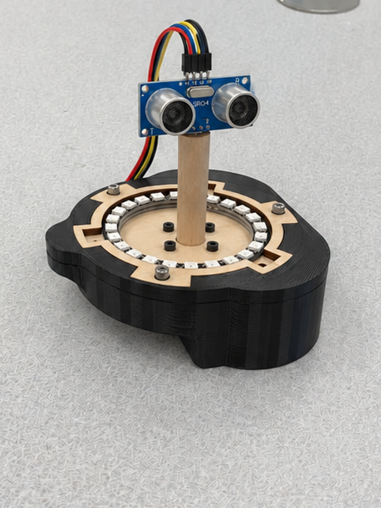
Figure 1. Assembled scanner with the HC-SR04 mounted on the wooden rotating riser.
Platform electronics, motor, driver, NeoPixel ring, and enclosure are reused. The application described here replaces the original display function with local ultrasonic scanning.

1 Features
- Adafruit Feather ESP32-S3 with 4 MB flash and 2 MB PSRAM [2].
- CircuitPython control with the existing custom sensor motor and NeoPixel libraries.
- HC-SR04 ultrasonic ranging sensor mounted on the rotating motor shaft.
- NEMA 8 stepper with 200 full steps per revolution and I2C motor control [1].
- Initial back-and-forth scan from 0 to 180 degrees.
- Synchronized motor angle, distance, and validity data over USB serial.
- Live Python 2D radar-style range map on the connected computer.
- Twenty-four individually addressable RGB LEDs for scan and status feedback.
- Existing printed enclosure, magnetic faceplate, and USB-C power connection.

2 Applications
- Visualizing nearby walls and large stationary obstacles in a horizontal plane.
- Studying acoustic ranging, motor positioning, and sensor synchronization.
- Demonstrating a complete sensing-to-visualization system for an engineering portfolio.
- Comparing repeated room scans while keeping the scanner at a fixed location.

3 Description
This custom sensor platform operates as a compact ultrasonic room scanner. The existing motor turns a wooden riser that holds the HC-SR04 above the ring and case, allowing the sensor to face a sequence of directions while the base remains stationary.
At each sample position, the motor stops briefly, the sensor measures the returning acoustic echo, and the processor associates the result with the commanded shaft angle. The computer converts the angle and range into a polar display. A missing echo is reported explicitly so that it cannot appear as a false object at zero distance.
The result is a horizontal slice of the surrounding space. The HC-SR04 has a broad acoustic beam and target-dependent reflections, so the displayed points represent approximate surfaces rather than a detailed geometric reconstruction. The scanner operates locally over USB; Wi-Fi and cloud services are optional extensions.

4 Inputs and Outputs
The HC-SR04 supplies distance information through a TRIG/ECHO pulse interface. Motor position comes from the commanded step count after the scan origin is established. The ESP32-S3 controls the original motor driver over the shared I2C bus, drives the NeoPixel ring, and streams measurement records to the computer.
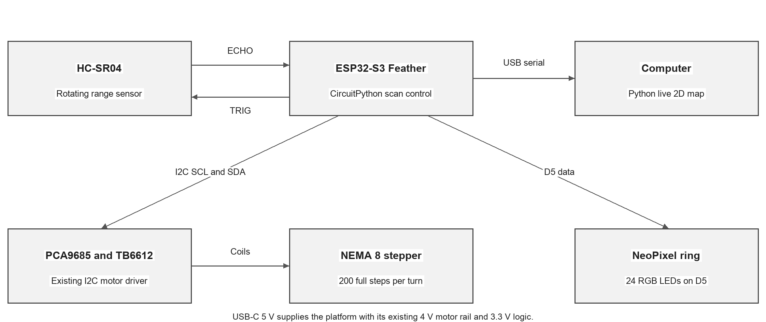
Figure 2. Scanner signal paths using the original custom sensor motor and display hardware.
Connection | Interface or mapping | Purpose
USB-C | 5 V power and USB serial | Powers the platform and carries scan records.
Motor driver | I2C through board SCL and SDA | MotorKit controls the PCA9685 and TB6612 coil outputs.
NeoPixel ring | D5; 24 RGB pixels | Displays scan position and measurement status.
Hall reference | D12 in the modified motor library | Retains the reference input rerouted from the original D16 trace.
HC-SR04 TRIG | Output GPIO at the installed sensor connection | Starts one acoustic measurement.
HC-SR04 ECHO | Input GPIO with 3.3 V level conditioning | Measures echo pulse duration.
Table 1. Hardware interfaces. The HC-SR04 GPIO numbers follow the installed wiring.
The recovered motorFunctions_GOLDEN_DO_NOT_CHANGE.py uses board.D12 for the Hall input; earlier DA8 and DA10 files use board.D16. The NeoPixel helper defines board.D5 and 24 pixels. The sensor connections must match the assembled TRIG and ECHO wiring, independently of these established platform assignments [1].

5 Absolute Maximum Ratings
Whole-system stress limits have not been characterized for the scanner assembly. Use the nominal conditions in Table 2 for operation. Individual component absolute maximum ratings do not establish a safe supply rating for the complete USB-powered platform.
The HC-SR04 ECHO signal uses a 5 V interface and is conditioned before reaching the Feather GPIO. The ESP32-S3 uses 3.3 V logic. The existing motor rail, logic rail, and sensor rail remain separate functions of the power system [2], [4].

6 Electrical Characteristics
Parameter | Value or condition | Basis
Platform input | 5 V nominal through USB-C | Existing platform supply
Logic level | 3.3 V | Feather GPIO and I2C
Stepper supply | 4 V nominal | Original PCB regulator design
HC-SR04 supply | 5 V nominal | Sensor specification [3]
HC-SR04 current | 15 mA typical | Sensor specification; excludes motor and LEDs [3]
Ring brightness | Reduced brightness during scanning | Application setting; total current depends on lit pixels
Environment | Dry indoor operation | Intended use; no enclosure environmental rating
Table 2. Nominal operating conditions. Total scanner current is load dependent.

6.1 Scanner Characteristics
Parameter | Initial specification | Interpretation
Scan travel | 0 to 180 degrees | Reverses at each endpoint.
Full-step increment | 1.8 degrees | 360 degrees divided by 200 steps.
Sample positions | 101 per half sweep | One reading at every full-step position, including endpoints.
Ping interval | More than 60 ms | Sensor timing requirement [3]; additional settling may be used.
Nominal sensor range | 2 to 400 cm | Vendor range, not a measured scanner guarantee [3].
Angular beam width | Approximately 15 degrees | Vendor value; finer stepping does not narrow the beam [3].
Map update | One update per sample | Angle and distance travel in the same serial record.
Table 3. Scanner settings and sensor specifications. Sweep time depends on settling and motion.

6.2 Measured Platform Characteristics
These results characterize the original custom sensor power PCB using a 10 ohm bench load. They are retained as electrical measurements of the reused platform. They do not measure the scanner's range accuracy, angular repeatability, total current, or sweep time [1].
Vin (V) | Vout (V) | Iin (mA) | Iout (mA) | Pin (W) | Pout (W) | Peff (%)
4.923 | 3.8412 | 447 | 376.3 | 2.201 | 1.445 | 65.66
Table 4. Original stepper supply efficiency measurement with a nominal 5 V input and 10 ohm load.
Vin (V) | Vout (V) | Iin (mA) | Deviation from 4 V (%)
4.0 | 3.2963 | 351 | 17.593
4.1 | 3.3847 | 367 | 15.382
4.2 | 3.4712 | 378 | 13.22
4.4 | 3.6391 | 412 | 9.023
4.6 | 3.7412 | 425 | 6.47
4.8 | 3.8714 | 433 | 3.215
5.0 | 3.9083 | 448 | 2.292
5.2 | 3.9201 | 446 | 1.997
5.4 | 3.9114 | 450 | 2.215
5.6 | 3.9088 | 455 | 2.28
5.8 | 3.8741 | 461 | 3.148
6.0 | 3.8973 | 469 | 2.568
Table 5. Original motor supply input-voltage sweep under the 10 ohm bench load.
Vin (V) | Vout (V) | Percent difference of Vout from 4 V
5 | 3.9083 | 2.292
Table 6. Selected 5 V bench point from Table 5. The 2.292 percent deviation exceeds 2 percent.
At the 5 V bench point, the input-to-output difference is 1.0917 V. The original single-point entry therefore does not establish a minimum dropout voltage for a 2 percent output tolerance. The 5.2 V input row is the only recorded point below 2 percent deviation; this isolated result is not a qualified operating range.

6.3 Modeled Platform Characteristics
The following regulator model and simulation data are retained from the original custom sensor design work. They provide historical design context for the reused motor supply. Simulated inputs outside nominal USB operation are not scanner operating settings [1].
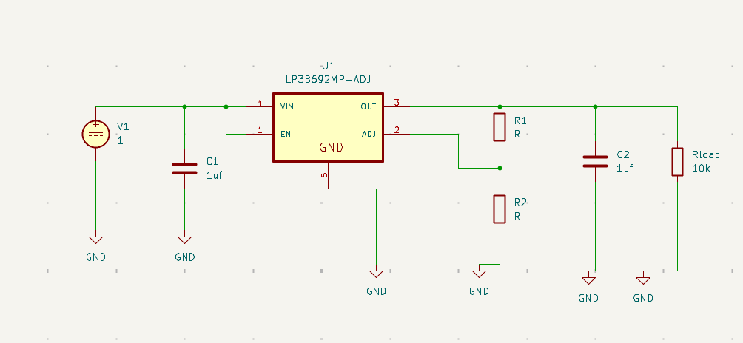
Figure 3. Original motor supply regulator simulation circuit.
Vin (V) | Vout (V)
5 | 4
4 | 2.54
3 | 2.54
2 | 1.55
1 | 0.00178
10 | 1.8
3.5 | 3.04
3.8 | 3.34
3.7 | 3.24
6 | 3.87
4.2 | 3.74
3.99 | 3.53
4.3 | 3.84
Table 7. Archived simulated input and output voltages from the original regulator model.
Rload (ohm) | Vin (V) | Iin | Vout (V) | Iout | Efficiency (%)
10k | 5 | 1.02 mA | 4 | -1.02 mA | 80
8k | 5 | 1.11 mA | 3.88 | -1.11 mA | 77.6
5k | 5 | 1.4 mA | 3.88 | -1.4 mA | 77.6
1k | 5 | 4.13mA | 4 | -4.13mA | 80
500 | 5 | 8.13mA | 4 | -8.13mA | 80
100 | 5 | 40.1mA | 4 | 40.1mA | 80
50 | 5 | 80.1mA | 4 | 80.1mA | 80
10 | 5 | 400mA | 4 | 400mA | 80
1 | 5 | 1.5A | 1.5 | 1.5A | 30
Table 8. Archived load-regulation and efficiency simulation. Current signs follow the source model.

6.4 Regulator Startup and Measurement Timing
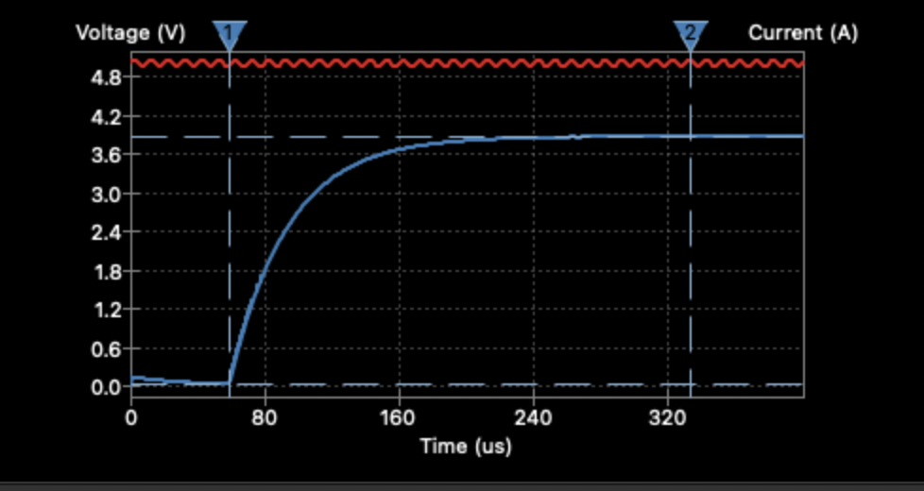
Figure 4. Regulator startup plot retained from the original datasheet.
The original report lists a modeled turn-on time of approximately 274 microseconds. It separately records a measured turn-on figure of 118 microseconds and a 10 to 90 percent rise time of about 96 microseconds from the DA5 capture. Those values use different timing definitions and should be compared only with matching thresholds [1].

Acoustic Ranging Model
The sensor emits an ultrasonic burst and measures the round-trip echo duration. The range estimate is d = c times t divided by 2, where t is echo time and c is the speed of sound. A fixed sound-speed conversion introduces temperature dependence. Surface angle, material, target size, and multipath also affect the return [3], [4].
A complete 0 to 180 degree half sweep contains 100 full-step moves and 101 sample positions. A 65 ms minimum ping period gives a theoretical acquisition floor of about 6.6 seconds for 101 readings; motor motion, settling, serial transfer, and timeouts can lengthen the actual sweep. This is a timing calculation rather than a measured result.
The measurement cycle is move, settle, trigger, capture, validate, and publish. The shaft is stationary while the echo is timed. Motion resumes only after that measurement finishes or times out. The nominal 1.8 degree sampling interval defines sample spacing; it does not imply 1.8 degree acoustic resolution.

7 Detailed Description

7.1 Functional Block Diagram
Figure 2 shows the complete signal path. The ESP32-S3 schedules motor moves, triggers the HC-SR04, processes echo timing, updates the ring, and emits a serial record. The computer receives those records and maintains the latest valid range at each scan angle. The fixed base defines the map origin.

7.2 Feature Description

7.2.1 Power System
USB-C supplies nominal 5 V to the platform. The existing PCB provides the motor supply at approximately 4 V, while the Feather provides the 3.3 V logic domain. The HC-SR04 uses the 5 V sensor supply and a common ground. Its ECHO connection is reduced to the logic level accepted by the ESP32-S3. NeoPixel brightness is limited to keep the display current modest [1], [2], [4].

7.2.2 Sensors
The HC-SR04 is fixed to the wooden riser with its transducers facing outward, above the case and ring. TRIG starts an individual measurement; ECHO provides a pulse whose duration represents the acoustic round trip. No echo, a timeout, or an out-of-range value produces an invalid sample rather than a zero-distance point. The sensor remains level so each sweep measures approximately the same horizontal plane [3], [4].

7.2.3 Software and Processor
The existing board target is adafruit_feather_esp32s3_4mbflash_2mbpsram. The archived platform setup uses CircuitPython 9.2.9. The application retains motorFunctions.ECEGMotor, adafruit_motorkit, adafruit_motor, adafruit_pca9685, the original NeoPixel helper, and their dependencies. HC-SR04 ranging uses adafruit_hcsr04 or an equivalent pulse-timing routine matched to the installed board [1], [4], [5].
The scan controller owns the angle and direction. Motor control owns the step count. Sensor acquisition owns pulse timing and validation. Serial output carries complete measurement records. The computer owns plotting and optional file capture. This separation keeps display updates from changing motor position or sensor timing.

7.2.4 Connectivity
Native USB serial connects the scanner to the computer. A normal host setting is 115200 baud; native USB CDC carries data over USB rather than a physical UART at that bit rate. Wi-Fi hardware remains available, but the scanner does not require internet access, API keys, weather services, or a cloud channel [2].

7.2.5 Display and Motion

7.2.5.1 NeoPixel Ring
The existing ring contains 24 RGB pixels on D5. A moving marker follows scan position, while color communicates the latest result. Use blue during initialization, green for a valid distant return, amber for a nearby return, a dim red marker for an invalid echo, and a steady red fault indication when the scan cannot continue. A single invalid echo does not stop the sweep.
Condition | Ring indication | Computer display
Initializing or setting origin | Blue | Waiting for the first sample.
Valid sample beyond near threshold | Green position marker | Range point and current scan ray.
Valid sample within near threshold | Amber position marker | Nearby return at the measured range.
No valid echo | Dim red position marker | Clear the prior point at this angle.
Motor or acquisition fault | Steady red | Fault status; preserve the last scan for inspection.
Table 9. Scan and status indications. The near threshold is an application setting.

7.2.5.2 Motor Arm and Sensor Riser
The existing NEMA 8 motor has 200 full steps per turn, or 1.8 degrees per full step. MotorKit controls the PCA9685 and TB6612 drive through I2C, using stepper1. In the course helper, BACKWARD advances clockwise and FORWARD advances counterclockwise. Preserve this convention and update the tracked position for every commanded step [1], [5].
The original motor library defines zero at 12 o'clock and retains a Hall reference near 3 o'clock. The scanner defines its own 0 degree endpoint with a mounting offset. After establishing that origin, it traverses 100 full steps to 180 degrees and returns along the same path. Reversing the sweep prevents repeated full-turn cable winding.
PCA command | AO1 (V) | AO2 (V) | BO1 (V) | BO2 (V)
h2A | 0 | 4.0531 | 0 | 0
h32 | 0 | 0 | 4.0618 | 0
h2E | 4.0487 | 0 | 0 | 0
h36 | 0 | 0 | 0 | 4.0512
Table 10. Original motor terminal voltage measurements from the custom sensor build [1].

7.2.5.3 Computer Map
The map shows scan angle across a semicircle and range in centimeters. With 0 degrees at the left endpoint, use x = -d cos(theta) and y = d sin(theta), or plot directly in polar coordinates. Keep one latest return per angular bin, show the current ray even for an invalid echo, and replace stale data as the next sweep reaches each angle.

8 Application and Implementation

8.1 Room Scanning Application
Place the scanner at a fixed location with the sensor axis horizontal. The motor sweeps the HC-SR04 through the selected half-plane, the ring shows progress, and the connected computer displays the current range profile. Large flat targets generally produce clearer returns than fabric, narrow objects, or surfaces that reflect sound away from the receiver.

8.2 Setup
1. Retain the existing CircuitPython installation for the Feather ESP32-S3 4 MB flash and 2 MB PSRAM board. Keep a copy of the working custom sensor files and libraries.
2. Use the original MotorKit-based motor helper and NeoPixel helper. Preserve D5 for the 24-pixel ring and the modified D12 Hall input. Map the sensor TRIG and ECHO names to the GPIO actually used by the installed wiring.
3. Configure a 0 to 180 degree scan, 200 full steps per revolution, and one initial sample per full step. Start with a 65 ms minimum interval between pings and add settling time as needed.
4. Define the scan origin at the sensor's left endpoint. Enter the mounting offset between this direction and the motor library's 12 o'clock zero. Re-establish the origin after moving the shaft by hand.
5. On the computer, install Python, pyserial, NumPy, and Matplotlib. Select the Feather USB serial port and close other programs that hold the same port.
6. Open the live map, select a range limit in centimeters, and begin scanning. Confirm the first sweep reverses at the intended endpoints.

8.3 Serial Data
Each completed acquisition produces one newline-delimited JSON record. Angle, range, and validity belong to the same physical sample. Invalid returns use null for the distance; they must not be converted to a range of zero. A sample record is shown below.
{"type":"sample","angle_deg":45.0,"distance_cm":123.4,"valid":true}
{"type":"sample","angle_deg":46.8,"distance_cm":null,"valid":false}
For recorded experiments, add a monotonically increasing sequence number, acquisition timestamp, and sweep identifier. The host can then detect missing records, calculate update rate, and separate clockwise from counterclockwise scans. Console messages that are not valid sample records are ignored by the plotting input.

8.4 Operation
Initialize the hardware, establish the scan origin, and start at the 0 degree endpoint. Move one full step, allow the riser to settle, take one range measurement, publish it, and update the ring. At 180 degrees, reverse direction; at 0 degrees, reverse again. Sample the endpoints once on each pass. Keep the step count and direction authoritative so the reported angle follows the actual command sequence.
The plot refreshes whenever a sample arrives. Valid echoes replace the prior point at that angle; invalid echoes clear it. The display should retain scan direction and the current ray even when no object is detected. A serial disconnect pauses incoming updates; reconnect and re-establish the scan origin if the board restarted.

8.5 Calibration and Verification
Use the following procedure to evaluate the scanner under controlled conditions. These checks define the verification method; the electrical values in Section 6.2 remain the recorded results of the earlier PCB tests.
Check | Procedure | Record or acceptance
Angular scale | Command 0, 90, and 180 degrees from the established origin. Compare with a protractor or fixed marks. | Record endpoint and midpoint errors. Verify exactly 100 full steps per half sweep.
Range check | Face a large flat target at measured distances such as 50, 100, and 200 cm. Collect at least 20 stationary readings at each distance. | Record mean error, spread, and invalid-return fraction.
Repeatability | Run at least 10 complete back-and-forth cycles without moving the base. | Compare a fixed target in both directions and check for accumulated endpoint drift.
Missing echoes | Use a direction with no usable return, then restore a target. | Confirm null/invalid records and removal of stale map points; valid points return when echoes recover.
Serial and map | Compare a sample angle and distance in the stream with the plotted location. | Confirm matching units, orientation, sweep direction, and displayed ray.
Timing and endurance | Log sequence numbers and timestamps during an extended scan. | Report sample interval, half-sweep duration, record gaps, and any reset or stall.
Table 11. Verification procedure for the assembled room scanner.
A broad ultrasonic beam can merge nearby surfaces into one return. Sampling more finely cannot recover detail that the acoustic measurement does not resolve. Keep distance accuracy, angular repeatability, beam width, and map appearance as separate evaluation results.

9 Mechanical Layout and Dimensions
The scanner reuses the custom sensor PCB, printed enclosure, and NeoPixel faceplate. The HC-SR04 sits on the existing wooden rotating riser above the center shaft, as shown in Figure 1. The transducers remain above the case so their forward acoustic path is not blocked by the ring or enclosure.

9.1 Printed Circuit Board
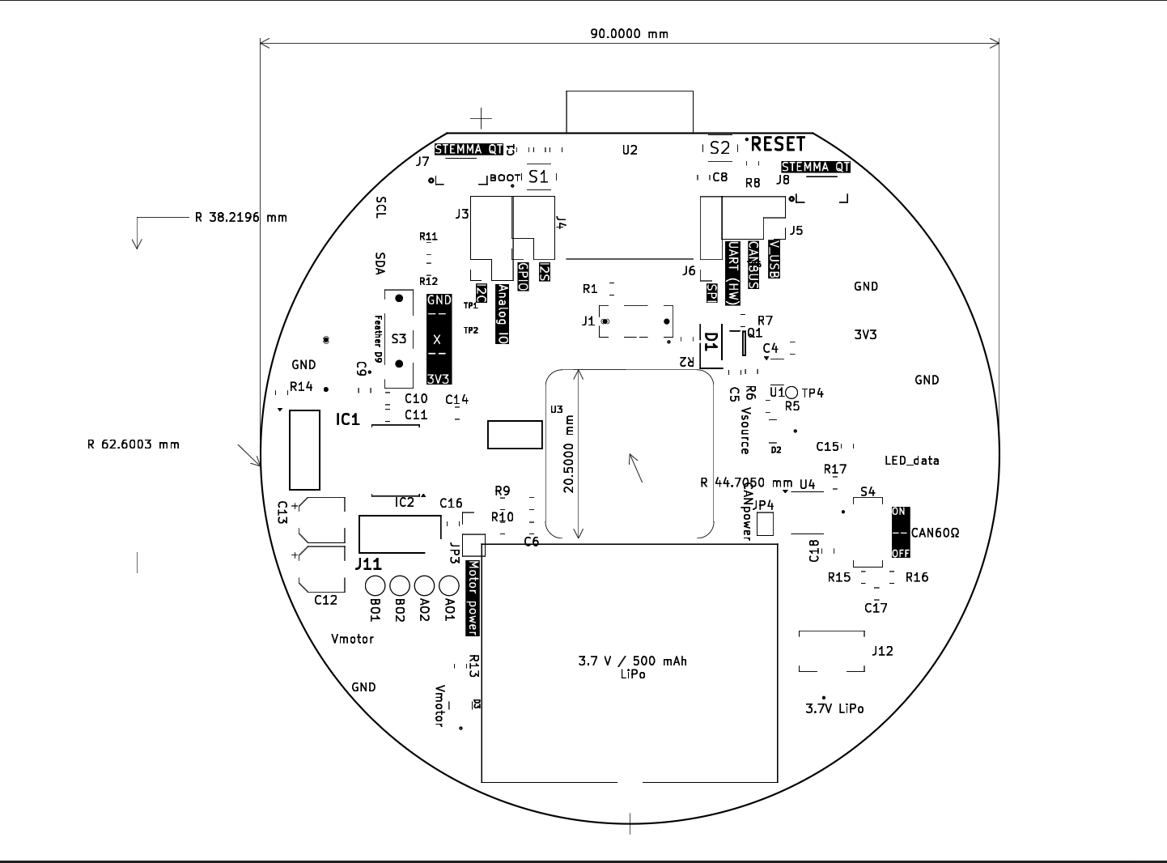
Figure 5. Original custom sensor PCB mechanical layout with the 90 mm overall board dimension [1].

9.2 Case and Sensor Mount
The black printed case supports the existing PCB and motor. The wooden faceplate surrounds the 24-pixel ring, and the upright wooden riser carries the ultrasonic module. The module is oriented so the scan plane remains horizontal. Keep the sensor-to-shaft alignment fixed when comparing scans.
The original CAD archive includes clockarm.stl and Arm.glb. The PCB dimension shown above is not a measurement of the printed case diameter. Sensor height, riser dimensions, and final case dimensions are assembly-specific and should be dimensioned from the finished part before fabricating replacements.

10 Citations
[1] M. McCormack, custom sensor platform datasheet and project archive, ECEG 201, Bucknell University, Spring 2026. Hardware evidence: motorFunctions_GOLDEN_DO_NOT_CHANGE.py, Submissions/DA8/neopixelFunctions.py, the archived board-target URL, original PCB drawing, and DA5/DA1 measurements and simulations. Scanner assembly photograph supplied by the author.
[2] Adafruit Industries, Adafruit ESP32-S3 Feather with 4 MB Flash and 2 MB PSRAM, product 5477 and board guide. https://www.adafruit.com/product/5477 and https://learn.adafruit.com/adafruit-esp32-s3-feather. Accessed 26 October 2026.
[3] ElecFreaks, Ultrasonic Ranging Module HC-SR04, datasheet. https://cdn.sparkfun.com/datasheets/Sensors/Proximity/HCSR04.pdf. Accessed 26 October 2026.
[4] Adafruit Industries, Ultrasonic Sonar Distance Sensors, Python and CircuitPython guide. https://learn.adafruit.com/ultrasonic-sonar-distance-sensors/python-circuitpython. Accessed 26 October 2026.
[5] Adafruit Industries, CircuitPython MotorKit Library, API reference. https://docs.circuitpython.org/projects/motorkit/en/stable/api.html. Accessed 26 October 2026.
The nominal HC-SR04 range and beam width are vendor specifications. The original electrical tables and figures describe the reused custom sensor platform. Derived acquisition timing is identified as a calculation; scanner accuracy and repeatability are evaluated using the procedure in Section 8.5.

